**NAGIOS**

Alternates: SPLUNK, KIBANA, PROMETHEUS, ELK, SENSU, LIBRATO

* It is an open-source software for continuous monitoring of systems, networks an Infrastructure.
* It runs plugin stored on server which is connected with a host or another server on your network or the internet.
* In case of any failures Nagios alerts about issue so that technical team can perform recovery process immediately.

**HISTORY**

* In 1999, Ethan Galstad developed it as a part of **Netsaint** distribution.
* 2000, he renames the project to **Nagios** because of trademark issues with **Netsaint**.
* In 2009 Nagios released it first commercial version Nagios X1.
* In 2012 Nagios renamed as Nagios Core.
* It uses 5666, 5667 and 5668 to monitor its clients.

**Why Nagios**

* Detect all types of networks, or server issues.
* Helps to find out root cause of problem which allow you to get permanent solution.
* Reduce Downtime.
* Active monitoring of entire infrastructure.
* Allow you to monitor and troubleshoot server performance issues.
* Automatically fix updates.

**FEATURES**

* Old and latest.
* Good log and database system.
* Informative and attractive web interface.
* Automatically sends alerts if condition changes.
* Helps you to detect network or errors or server crashes.
* You can monitor the entire business process and IT infrastructure with single pass.
* Monitor network services like HTTP, SMTP, SNMP, FTP, SSH, POP, DNS, LDAP, IPMI, etc.

**PHASES OF MONITORING**

* **DEFINE**: Develop a monitoring Strategy.
* **ESTABLISH**: How frequently you are going to monitor it.
* Implement.
* Analyze data and report finding.
* Respond.
* Renew and Update.

**NAGIOS ARCHITECTURE**

* It is a client-server Architecture usually on a network, a Nagios server is running on a host and plugins are running on all the remote host which should you monitor.

**HOW IT WORKS**

* Mention all the details in configuration files.
* Daemon red these details what data is to be collected.
* Daemon use NRPE plug-in to collect data from nodes and store in its own database.
* Finally shows everything.

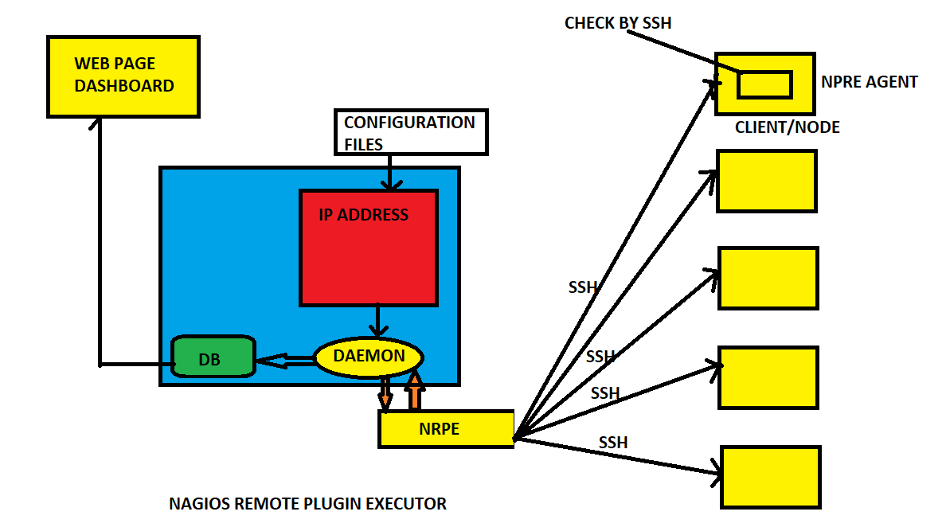

**PRE REQUISTES**

* HTTPD : Browser
* PHP : Dashboard
* GCC & GD : Compiler
* MAKEFILE : To build
* PERL : Script
* Main config file : /usr/local/nagios/etc/nagios.cfg
* All monitoring things are called as service.
* EX: 5 Servers -- > 4 check each you have to monitor -- > 5*4=20 Services.

**DASHBOARD OVERVIEW**

In dash board you can see

* HOST --- > Down

Unreachable

Up

Recovery

None

* SERVICES --- > Warning

Unknown

Critical

Recovery

Pending

* To reach the Nagios Ip/nagios/

**INSTALLATION OF NAGIOS**

* To start Nagios core installation, you must have your EC2 instance and run and have already configured SSH access to the instance.
* Execute the commands one by one now
* sudo su
* Yum install httpd php
* Yum install gcc glibc glibc-common
* Yum install gd gd-devel
* useradd nagios
* passwd nagios
* groupadd nagiosgrp
* usermod -a -G nagiosgrp nagios
* usermod -a -G nagiosgrp apache
* mkdir ~/downloads
* cd ~/downloads
* get https://assets.nagios.com/downloads/nagioscore/releases/nagios-4.4.5.tar.gz
* wget https://nagios-plugins.org/download/nagios-plugins-2.2.1.tar.gz
* tar zxvf nagios-4.4.5.tar.gz (x=extract, v=verbros, f=forcefully)
* cd nagios-4.4.5
* ./configure --with-command-group=ngroup
* make all
* make install
* make install-init
* make install-config
* make install-commandmode
* vim /usr/local/nagios/etc/objects/contacts.cfg (can configure user user details here)
* make install-webconf
* htpasswd -c /usr/local/nagios/etc/htpasswd.users nagiosadmin
* service httpd restart
* cd ~/downloads tar zxvf nagios-plugins-2.2.1.tar.gz
* ./configure --with-nagios-user=nagios --with-nagios-group=nagios
* make & make install
* systemctl enable nagios.service
* /usr/local/nagios/bin/nagios -v /usr/local/nagios/etc/nagios.cfg
* Now it wil give total warnings and error is zero. It is pre flight check.
* systemctl restart nagios s
* systemctl status nagios
* Service httpd restart
* Copy your public ipv4 and paste it on browser like this (ipv4/nagios/)
* It will ask username & password then you will see the UI.

